Report

Date | 19 September 2026
Team ID | MCA
Project Name | Online Learning Engagement and Student Performance Analysis
Maximum Marks | 5 Marks

A report is a detailed document that presents data, analysis, findings, and important insights in an organized way. It helps users understand the data clearly and is useful for decision-makers, analysts, and other stakeholders.
Creating a report in Power BI involves connecting the required data sources, creating visualizations such as charts and graphs, and arranging them properly on the report page. The visualizations can be formatted and customized to make the report clear, attractive, and easy to understand. Interactive features can also be added so users can explore the data. The report should be designed according to the needs of the target audience and should clearly present the important insights. After creating the report, feedback can be used to make improvements and increase its usefulness.
Report 1: Global Online Learning – Student Performance & Engagement Overview
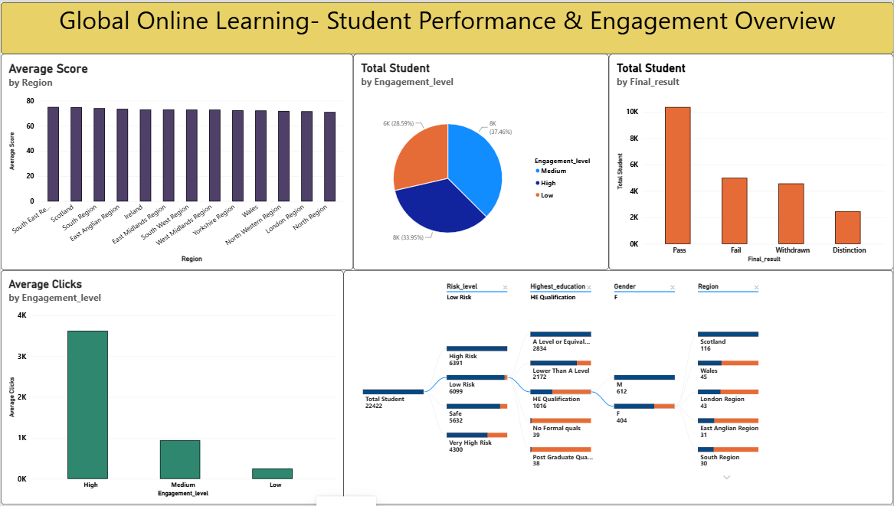
Observations drawn from reports in Power BI can provide valuable insights into business performances.
1. Performance Comparison
Average score by region
Average score across different regions is mostly in the 70s.
Comparison of student performance across regions.

2. Student Engagement Analysis
Total students by engagement level.
Engagement levels include High, Medium, and Low.
Average clicks are highest for the High engagement group.
3. Final Result Analysis
Students are grouped into Pass, Fail, Withdrawn, and Distinction.
Pass is the largest final-result category.
The dashboard also shows final results by engagement level.
4. Regional Analysis
Student performance is compared across different regions.
The dashboard shows the average score for each region.
5. Key Findings
Total students: 22,422
High engagement has the highest average clicks.
Pass is the largest final-result category.
Average scores across regions are mostly around the 70s.
Report 2: Risk, Dropout & Demographic Analysis Dashboard
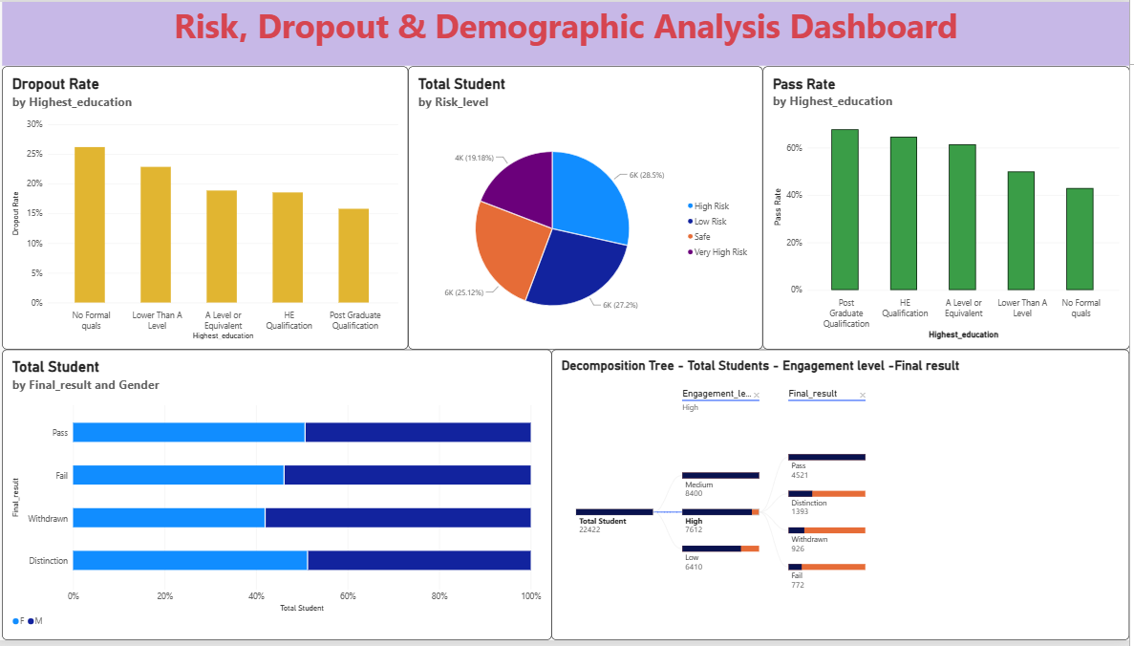
1. Risk Analysis
Students are divided into High Risk, Low Risk, Safe, and Very High Risk. The dashboard compares the number of students in each risk category.
2. Dropout Analysis
Dropout rate is compared across different highest-education groups.
The highest visible dropout rate is for No Formal qualifications.
The lowest visible dropout rate is for Post Graduate Qualification.
3. Pass Rate Analysis
Pass rate is compared by highest education.
Post Graduate Qualification has the highest visible pass rate.
No Formal qualifications has the lowest visible pass rate.
4. Demographic Analysis
Student distribution is shown by Gender and Region.
The dashboard compares male and female students across final-result categories.
Regions such as Scotland, Wales, London Region, East Anglian Region, and South Region are visible in the analysis.
5. Final Result and Gender Analysis
Final results include Pass, Fail, Withdrawn, and Distinction.
The chart compares the distribution of male and female students for each final-result category.
6. Key Findings
Total students: 22,422
Four risk categories are shown.
Dropout rate varies by highest education.
Pass rate varies by highest education.
Final results are compared by gender.

